## CALL FOR ARTISTS:

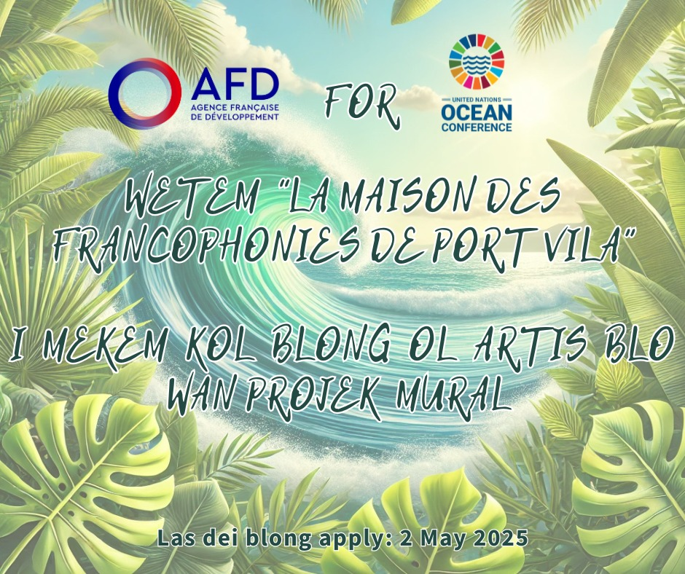

**Who are we and what do we do?**

## AFD, or Agence Française de Développement, is a French public institution that finances and implements projects worldwide. We work closely with local stakeholders, respecting their development priorities in sustainable economic, social, and environmental terms. Our actions are guided by the 17 United Nations Sustainable Development Goals (SDGs).

In the Pacific, we are especially committed to supporting island countries and territories in addressing climate change and protecting biodiversity on land and at sea. We pursue these goals in cooperation with local governments and by involving local communities, with special attention given to vulnerable groups (women, youth, remote populations).

**AFD’s Core Values**

- International solidarity: commitment to reducing global inequalities, promoting inclusive development models, and protecting common goods — especially biodiversity.  
- Sustainable development: respect for future generations, pursuit of the SDGs with a focus on climate, biodiversity, and improving daily life.  
- Partnerships and innovation: working together to address complex challenges.

## Context:

AFD supports the Maison des Francophonies of Port Vila (MdF), a recently founded grassroots association promoting solidarity, inclusion, and sustainable development, while playing a key role in Francophone regional cooperation. Supported by the Municipality of Port Vila and the Ministry of Education of Vanuatu, MdF operates both locally and regionally to strengthen ties between Francophone communities in the Pacific.

## Together, AFD and MdF wish to anchor their shared commitment to ocean protection by bringing an artistic and colorful touch to the MdF site, which also hosts the AFD office in Vanuatu — a mural symbolizing their shared vision of inclusive and sustainable development.

This artwork, which highlights the richness of the Pacific Ocean, will be unveiled during the United Nations Ocean Conference (UNOC, June 9–13), at the official inauguration of the Maison des Francophonies (Port Vila Day, June 11).

## Mural Theme:

"Oceans, Sustainable Development & Local Communities"  
The mural should highlight the richness of the Pacific Ocean, raise awareness on marine environment protection, and reflect local sustainable development challenges.

**Eligible Artists:**

- Individual artist or collective based in Vanuatu;  
- Experience in mural painting or street art is appreciated.

**Practical Information:**

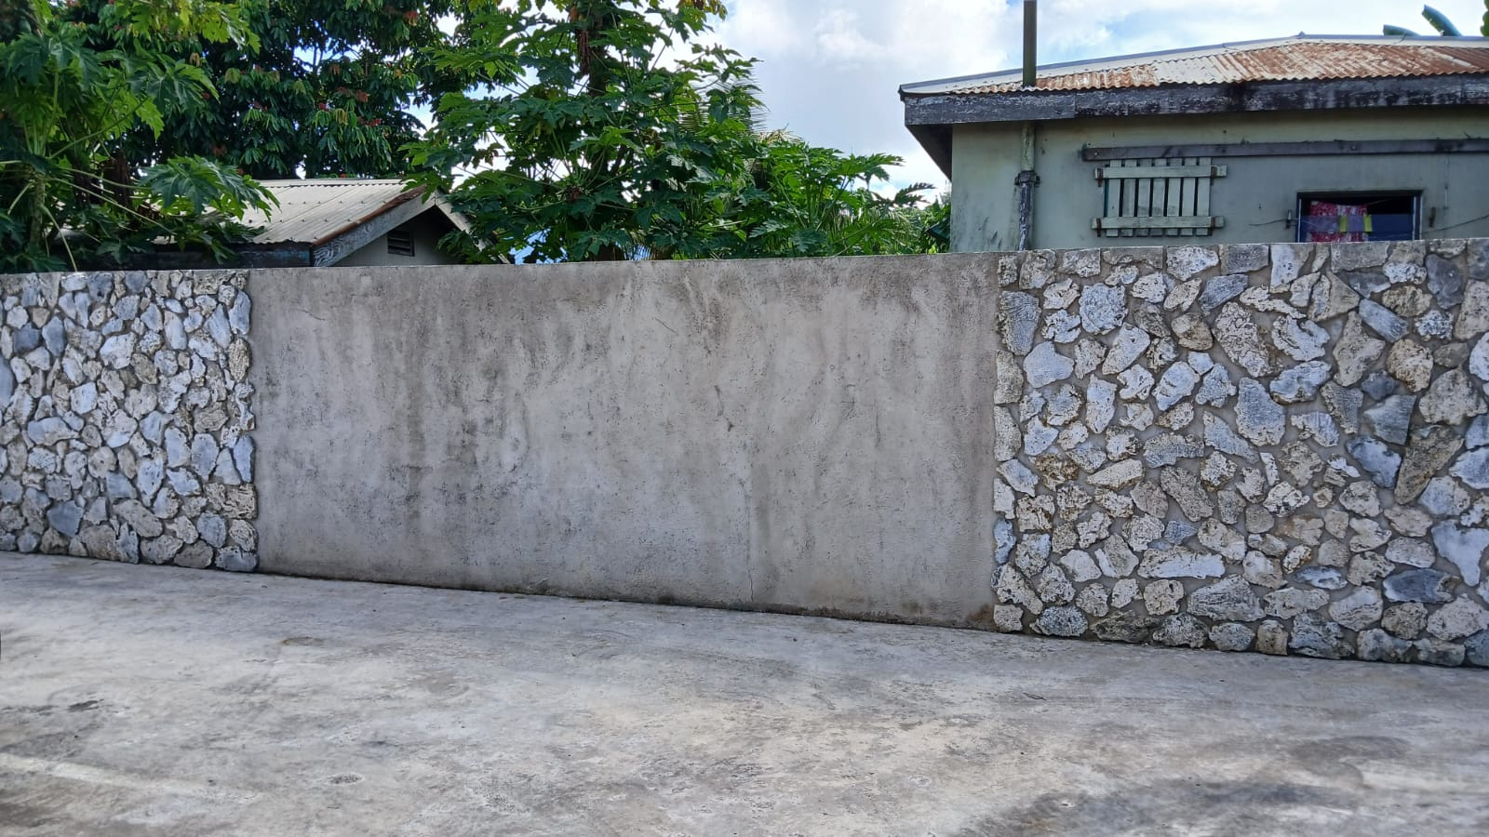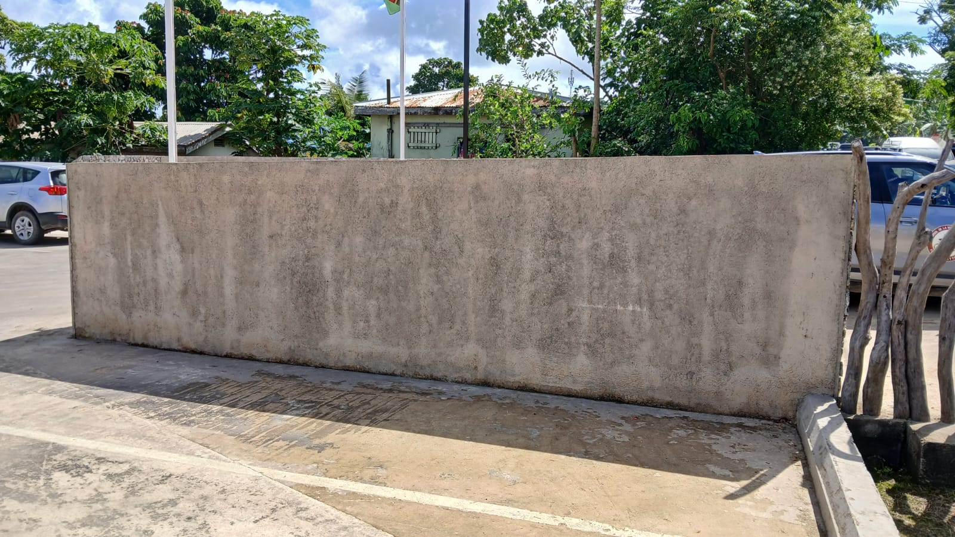Location: Maison des Francophonies of Port Vila, Dumbéa Roundabout, Port Vila, Shefa  
Wall surface: Two concrete wall sections located in the parking area of the Maison des Francophonies  
Approximate dimensions:  
Wall 1: Length: 6.35 m / Height: 1.70 m Wall 2: Length: 4.40 m / Height: 1.84 m

Total budget: MAXIMUM 450,000 VUV (all-inclusive, including materials, paint, labor, transport, and work time)

Required Materials: The mural must be made using high-quality professional products, suitable for tropical weather conditions (rain, humidity, UV). The artist must demonstrate the durability of the materials to ensure the mural's longevity.

**Timeline:**

Application deadline: Friday, May 2, 2025  
Execution dates: Monday, May 19 to May 30, must be completed before June 1, 2025  
Unveiling: June 10 and 11 during the inauguration of the Maison des Francophonies on the occasion of UNOC and Port Vila Day

## Submission:

Please submit:  
- The completed technical form below, including budget and execution schedule  
- A sketch or draft (digital version and/or in A2 format if possible)

📧 By email to: afdportvila@afd.fr and maisondesfrancophoniespv@gmail.com

## 📬 and/or drop off directly at: Maison des Francophonies – Dumbéa Roundabout, Port Vila

**ANNEX: TECHNICAL SHEET – MURAL PROJECT**

To be completed and included in your application

**1. Applicant Identification**

Name of the artist / collective:  
............................................................................................

Name and contact of focal point / coordinator (if collective):  
............................................................................................

Email, phone number & WhatsApp:  
............................................................................................

Place of residence:  
............................................................................................

Portfolio / social media (link):  
............................................................................................

**2. Artistic Project Presentation**

Project title:  
............................................................................................

Mural description (1 page max – concept, message, symbolism):  
............................................................................................

Link with UNOC and the call for applications theme:  
............................................................................................

Link with the Maison des Francophonies:  
............................................................................................

**3. Visual & Aesthetic Aspects**

Artistic style (e.g., figurative, abstract, graphic, realistic, etc.):  
............................................................................................

Main color palette:  
............................................................................................

Sketch or draft (must be attached)

**4. Technical Specifications**

Planned dimensions (in meters):  
Width: ____ m  Height: ____ m

Target surfaces (walls, angles, etc.):  
............................................................................................

Products/materials used (type of paint, varnish, etc.):  
............................................................................................

*(Include brands and suppliers if possible, especially for tropical-resistant materials)*

Estimated durability (in years):  
............................................................................................

Protection method before unveiling/inauguration:  
............................................................................................

**5. Constraints & Logistics**

Estimated execution time (in days):  
............................................................................................

Specific technical/logistical needs (scaffolding, electricity, etc.):  
............................................................................................  
............................................................................................

Number of people involved (artists, assistants, etc.):  
............................................................................................

Other anticipated local constraints:  
............................................................................................

**6. Detailed Budget (Max: 450,000 VUV)**

| **Expense Item** | **Estimated Cost (VUV)** |
| --- | --- |
|  |  |
|  |  |
| **Other (specify):** |  |
| **TOTAL** |  |

**7. Execution Timeline**

Between Monday, May 9 and Friday, May 30, 2025